10/31/2019 Predict the Stock Close Price

Problems / Predict the Stock Close Price

Predict the Stock Close Price

Max. Marks: 100


Problem statement

CoworksIndia is an international food production company. It became an IPO organization a few years back. Recently, the company decided to investigate its share prices. The organization is hiring talented data science enthusiasts to analyze the stock prices of the company and provide some insights to the management of the company. You are also required to forecast the closing prices of the stock.

Data

Train.csv: Contains historical data for the stock price that can be used for model training and analysis [ ]

Test.csv: Contains the dates on which the stock close price must be predicted []

Results.csv: Contains the expected output format []

sample_submission.csv: Contains the expected format for uploaded predictions les Data description

Variable

Date

Open

High

Close

Volume

Name

Trading

De nition

Date of the stock

Opening day price of the stock

High price of the stock on the current day
Closing day price of the stock

Number of shares traded

Stock tickers name

Whether it's trading or not

Variable

Type

String

Float64

Float64

Float64

Int64

String

String

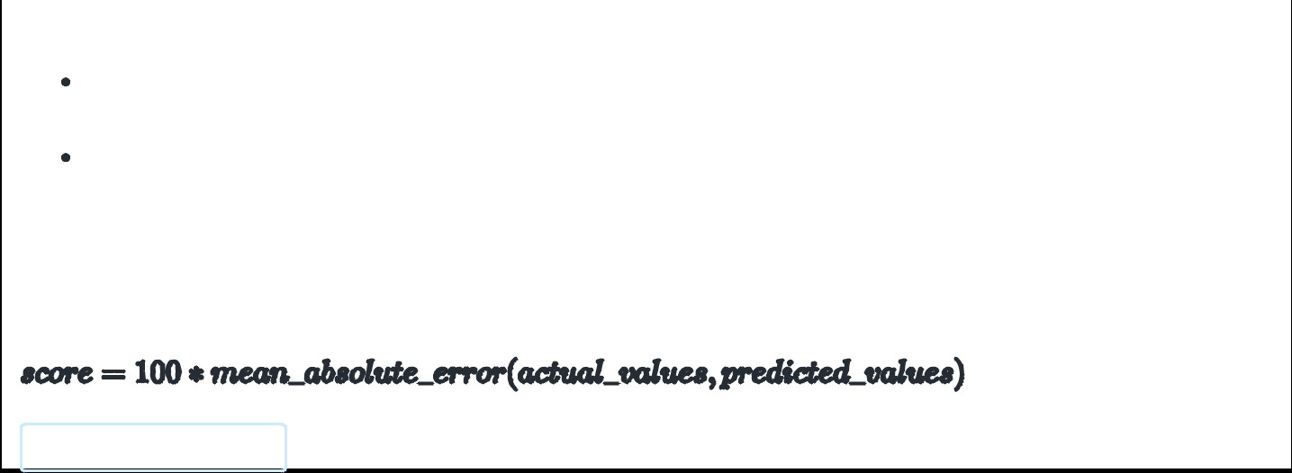

Submission format
Upload your predictions for the dates that are provided in the Test.csv ie into a .csv

Update your analysis of the historical stock data, your approach to solve the problem, logic used to solve the problem, and understanding of the problem statement in a .pptx ie.

Evaluation criteria

